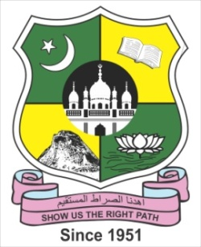 | DEPARTMENT OF HOTEL MANAGEMENT AND CATERING SCIENCE & B.VOC. TOURISM AND HOSPITALITY MANAGEMENT  JAMAL MOHAMED COLLEGE (Autonomous)  Accredited (3rd Cycle) with ‘A’ Grade by NAAC  (Affiliated to Bharathidasan University)  Tiruchirappalli - 620 020

World Food Day Celebration
INVITATION
We cordially invite you to participate in the Special Lecture Programme organized by our department to celebrate the
WORLD FOOD DAY

Date & Time: 18th Oct 2022 (Tuesday) at 10.30 a.m. Venue: Bio-Tech Gallery
In the august presence of
Hajee. M.J. Jamal Mohamed Bilal
President
Dr. A.K. Khaja Nazeemudeen, D.Litt.(USA)
Secretary & Correspondent
Hajee. M.J. Jamal Mohamed
Treasurer
Dr. K. Abdus Samad
Assistant Secretary
Dr. K.N. Abdul Kader Nihal
Member and Honorary Director
Dr. A. Jafar Ahamed
Coordinator, Dept. of Hotel Management & Catering Science
Welcomes the gathering

Dr. S. Ismail Mohideen
Principal, Jamal Mohamed College
Delivers the presidential address

Dr. S. Rajadurai

Senior Lecturer, Department of English Language Teaching,

University of Colombo, Sri Lanka.
Delivers a special lecture on
“English for Hotel Management and Tourism Professionals”

Felicitations by
Dr. A. Mohamed Ibraheem Dr. M. Mohamed Sihabudeen
Vice-Principal Additional Vice-Principal
Dr. K.N. Mohamed Fazil Ms. J. Hajira Fathima
Director-Hostel Administration Director-Hostel Administration (Women)
Mr. C. Thiyagarajan
Assistant Professor
Proposes a vote of thanks

